

Back – End Developer
Smart Job Portal System

Academic Year | Module | Assessment Number | Assessment Type
2026 | 5CS024 – Collaborative Development | Portfolio 1 | Individual Report

Student ID: 2462250
Student Name:Praju Maharjan
Group: L5CG9
Module Leader:Yogesh Bikram Shah
Tutor: Ms. Nerisha Shrestha
Submitted On: 20 March 2026
Table Of Contents
Self-appraisal form
Personal Objectives – Performance Measurement
Appendix A (Choosing Relevant Technologies)
Appendix B (Implementing Functional Requirements)
Appendix C (Use of Version Control)
Appendix D (Team Collaboration and Communication)
Collaboration Document
Good Communication and File Sharing
Continuing Personal Development
Issue Tracking
Work to Deadline
Sprint Retrospective
What Went Well
` What Could Be Improved
Actions For Improvement
Conclusion
References

Self-appraisal form

Student number | 2462250 | Name | Praju Maharjan
Project | Smart Job Portal System(KaamKhoji) | Date | 2026/04/20
Role | Developer | Team | L5CG9
Sprint (1 or 2) | 1

Personal objectives – Performance Measurement

Objectives | Evidence provided  (E.g. appendix A, file name etc.) | Evaluation  Student / tutor
Choosing Relevant Technologies | After numerous discussions, HTML, CSS, Vanilla JavaScript, PHP and MySQL were selected as the  final tech stack based on the project’s requirements, the simplicity and the team’s familiarity with the languages. Further evidence provided in Appendix A. | 9/10
Tutor feedback:

Implementing Functional Requirements | Three separate dashboards: Employee, job-seeker and admin were created ; each with their own functionalities, including job search and password changing. Further evidence provided in Appendix B. | 20/20
Tutor feedback:

Use of Version Control | Git and GitHub were extensively used to track changes to the code. To ensure that changes to the code did not break the working application, each additional feature was commited to a separate branch.  Further evidence provided in Appendix C. | 8/10
Tutor feedback:

Team Collaboration and Communication | The primary communication platforms for the team were Discord and WhatsApp. The Project Manager used Gmail to schedule regular online meetings on Discord while informal communication was carried out using WhatsApp messages.  Further evidence provided in Appendix D. | 8/10
Tutor feedback:
 |  | 45/50 | /50

Appendix A (Choosing Relevant Technologies)
The following programming languages and database were selected for the project :

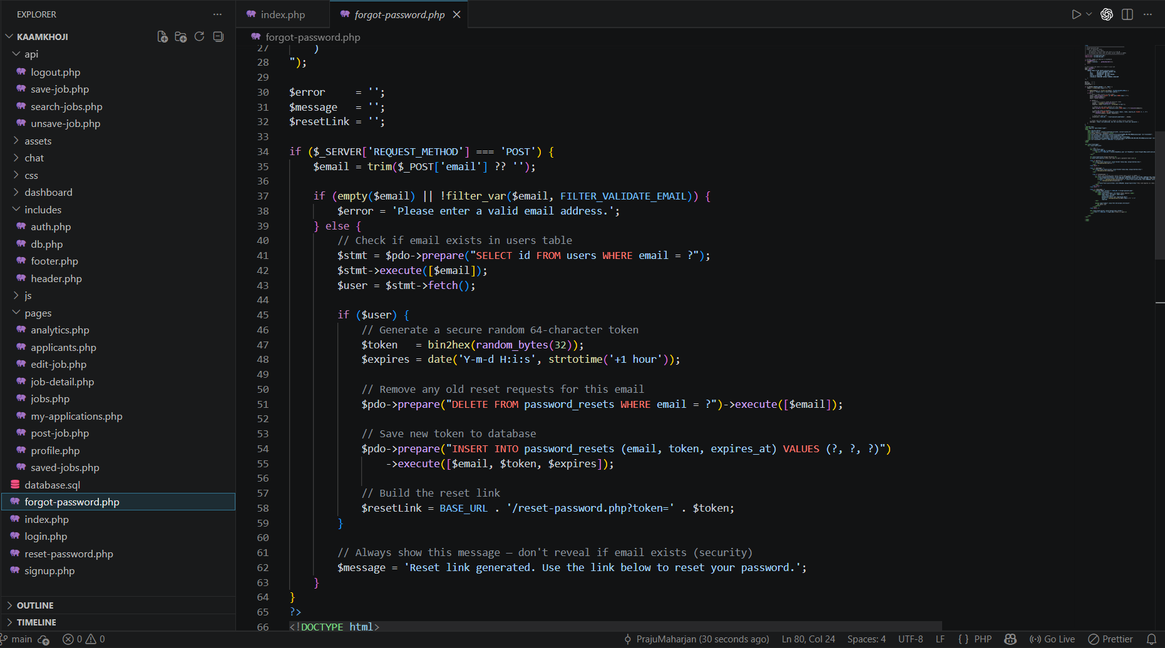

Fig :-1 File Structure of the application

Appendix B (Implementing Functional Requirements)

Appendix C (Use of Version Control)

Appendix D (Team Collaboration and Communication)

